Final Report

**Introduction:**

Welcome to **WildAustralia**, your gateway to discovering the vibrant and diverse essence of Australia. Begin your journey with our Intro section, where you'll find an engaging overview of what makes this website a must-visit for anyone interested in the land down under. Next, dive into the breathtaking beauty of Australia's most iconic landmarks, from the majestic Uluru to the stunning Great Barrier Reef, each meticulously detailed to spark your wanderlust. As you scroll further, immerse yourself in the rich diversity of Australian wildlife, showcasing the unique animals that call this continent home, from kangaroos to koalas and beyond. Our Culture section offers a deep dive into the rich tapestry of Australian traditions, art, and lifestyle, giving you a true sense of what it means to be Aussie. Finally, connect with us directly through our easy-to-use Contact Form, where your questions, feedback, or inquiries are always welcome. **WildAustralia** is your ultimate guide to exploring the wonders of Australia, all in one place.

Creating a professional website like **WildAustralia** using WordPress is crucial for showcasing your content effectively. With WordPress, you can easily design a visually appealing and functional site that highlights Australia's landmarks, animals, and culture. The platform's customizable themes and plugins allow you to tailor your site to reflect the unique essence of WildAustralia, ensuring it stands out. WordPress also offers strong SEO tools to help your website reach a broader audience, and its reliable security features keep your site safe. Whether you're sharing Australia's natural beauty or cultural richness, WordPress provides the ideal foundation for presenting WildAustralia in a professional and engaging way.

**Website Structure:**

We have designed the structure in such way that all the requirements are met.

**• Home / Welcome to Australia:**

Our website is single landing page that contains all the requirements. In the very first section of the website there a header or home page which contains an image elaborating the beauty of the Australian nature, along with the short introduction, there is also a button that will navigate the user towards the main website.

• **Australian Landmarks:**

After the home or intro section we have Australian Landmarks section that contains the 3 major attractive points of Australia for visitors. Those 3 areas are

* Sydney Opera house
* Great Barrier Reef
* Uluru

Details of all three areas are mentioned on the website.

**• Culture & Lifestyle**

In this section we have tried to explain culture and lifestyle in a single paragraph, that how people are enjoying their life, by enjoying music, festivals and other gatherings as well. After that we have used a picture of native image of the Australian people which are looking happy and showing the culture of Australia.

**• Australian Wildlife:**

In this section we have divided into 2 parts, one the picture part and the other is description part. In the picture part we have used a slider that contains the pictures of 3 animals as mentioned in the requirements. In the 2nd section we have the details and importance of those animals and how they are increasing the beauty of Australia.

3. Content Planning and Requirements:

We have used multiple sources for the content. In the wildlife section we do have used citations to confirm the source of the information. We have used multiple images and animations for the better attraction of the user.

4. WordPress setup:

First I have installed Xampp for hosting it locally, then I have downloaded WordPress form the official website of the WordPress, and then do the steps for setting up the WordPress. I have used Astra theme for my project and multiple plugins for multiple tasks as well. The plugins that I have used in this project are:

* Premium Addons
* Essential Addons
* Contact Form 7
* Yoast SEO
* Elementor
* Spectra
* Smart Slider

And many more.

**5. Customization:**

I have used Astra theme, and after observation and analysis I have designed a custom logo. The logo will be added in to the zip file. As my logo contains yellow color so I have used the combination of yellow, dark orange and many more.

**6. Navigation and Usability:**

I have created a menu bar and used anchor tag for navigation to that specific section. The website is fully functional and mobile responsive as well.

7. SEO Optimization:

I have installed Yoast SEO plugin for the SEO of my website, as the website shows the Australian culture and beauty, so I have used the keyword accordingly. The main strategy used for the SEO is to rank this website on those searches which shows the wildAsutralia Search.

8. Publication and maintenance:

I have used GitHub pages for the publication of my website and maintaing the web accordingly by updating the plugins as well.

9. Conclusion:

Wildaustralia website is designed to elaborate the beauty, culture and wildlife of Australia, we have developed this website by using WordPress, multiple plugins have been used for supporting. And we have done the publication of our website by using the GitHub pages.

Screenshots:

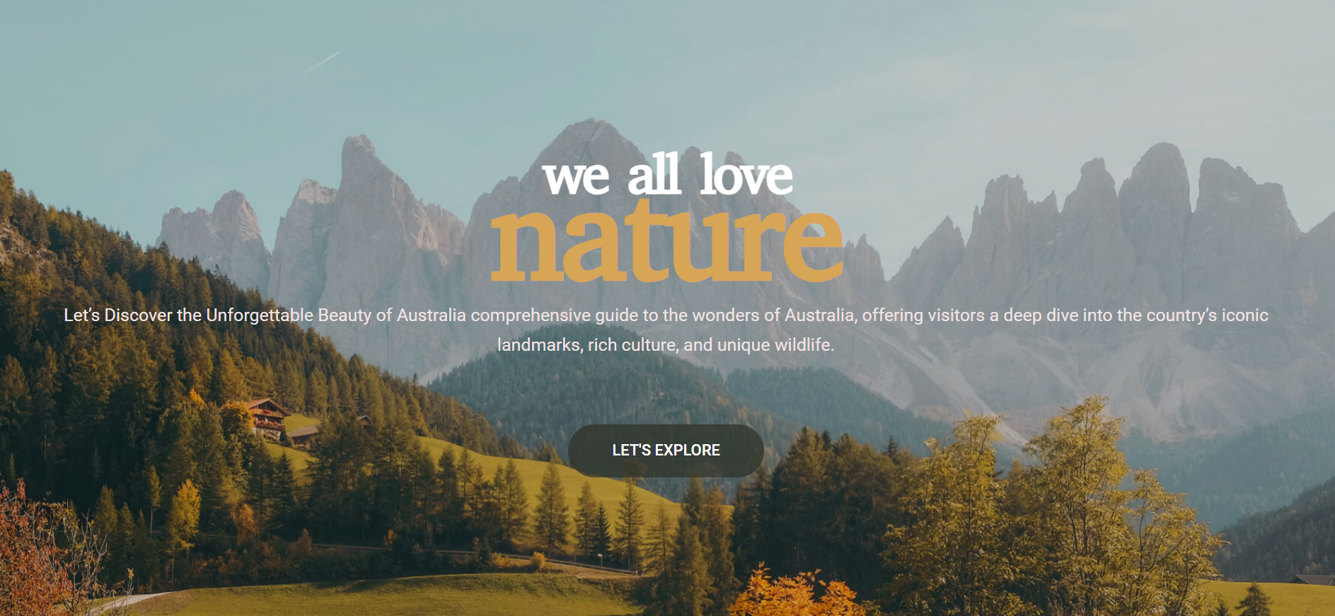

1Intro Section

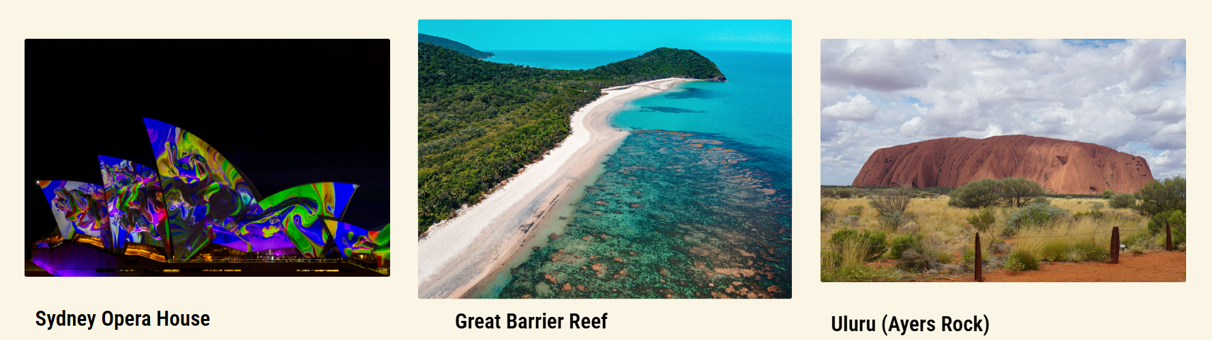

2 landmarks section

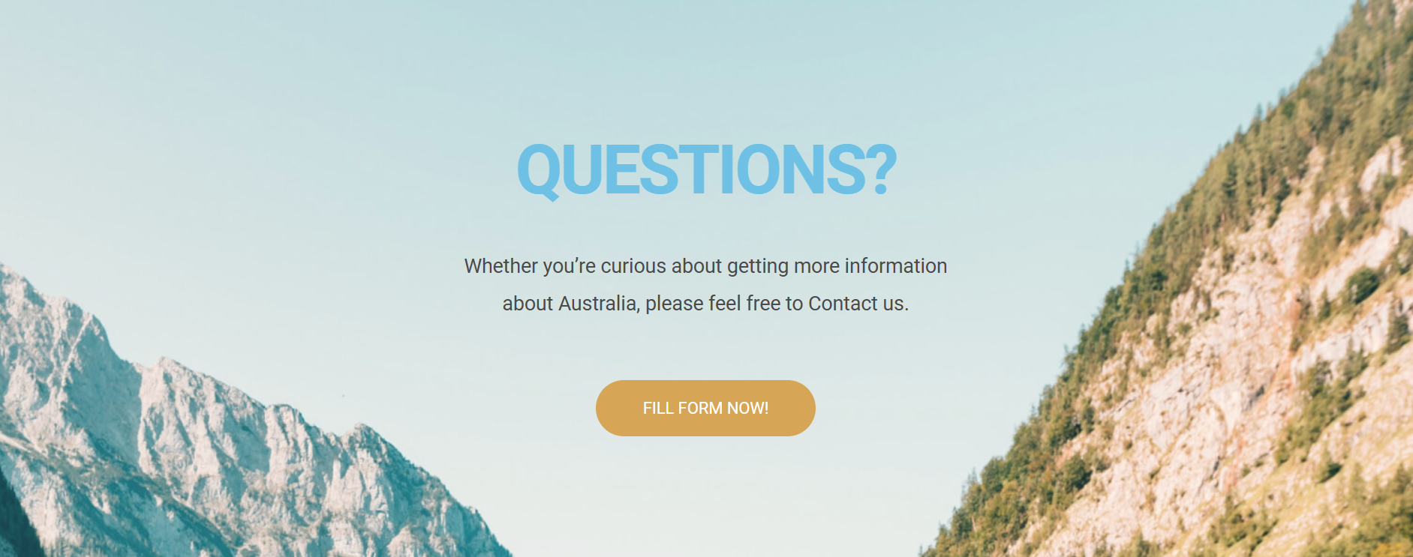

3 footer

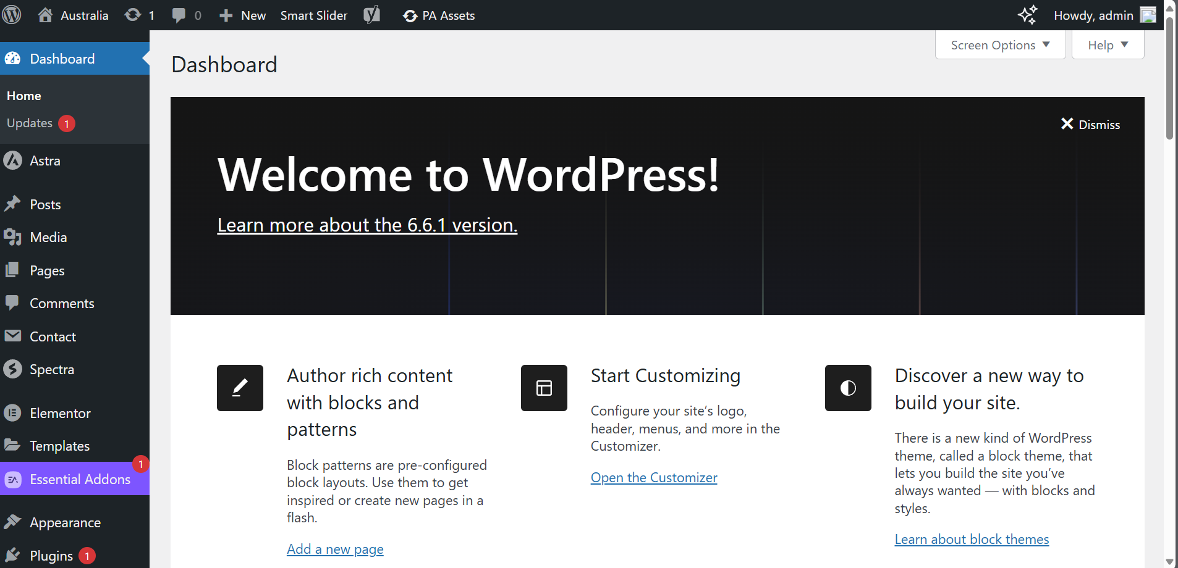

4 Dashboard